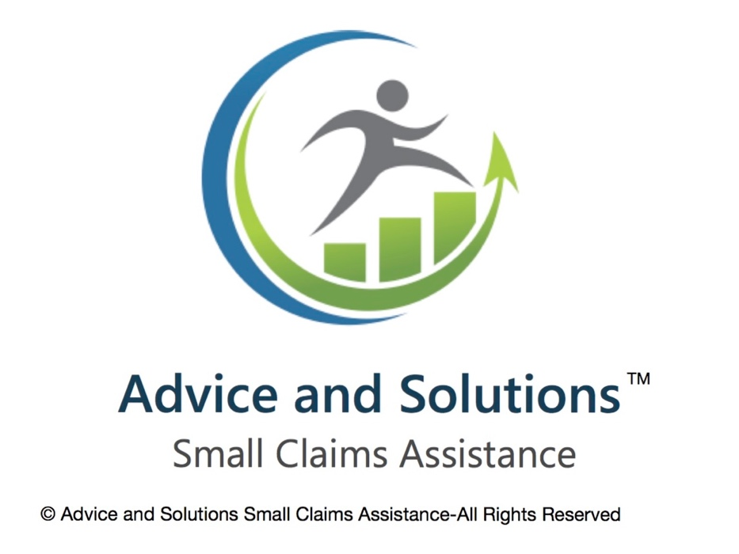
Make a claim against a person or organisation

Court Details
Part 1: Name of Court
In this section, you must provide the court’s name where the claim is being filed. If you are unsure, you can find the appropriate court based on the jurisdiction of your claim.
Claimant’s Details
Part 2: Claimant(s)
Full name, address, and contact details (email, phone number).
If you're making a claim on behalf of a company, provide the business name, registered address, and company number.
Defendant’s Details
Part 3: Defendant(s)
Name, address, and contact details of the defendant. If the defendant is a company, provide the company name, registered address, and company number.

Claim Details
Part 4: Brief Details of Claim
This section asks for a short description of the claim you are making. Try to keep it concise, focusing on the key facts that led to the dispute. For example, if it's a contractual claim, you could state: "The defendant failed to pay for services rendered under contract dated [Date]."
Value of the Claim
Part 5: Value of the Claim
You must state the value of the claim here. This includes the amount being claimed plus any interest, costs, or other sums.
If you’re unsure about the exact amount, you can estimate it and state that it's an "estimated value."
Claim Details (continued)
Part 6: Particulars of Claim
This is a more detailed description of the claim. You should include:
The cause of action (e.g., breach of contract, personal injury, debt recovery).
Key dates and events.
Amount owed or damages sought.
This section should give the court enough information to understand the nature of the claim.
Claimant’s Signature
Part 7: Signed by Claimant
The form must be signed by the claimant (or the solicitor acting on behalf of the claimant). If a solicitor is representing you, they should sign here.
Statement of Truth
A statement of truth is required. The claimant (or solicitor) will confirm that the information in the claim form is accurate to the best of their knowledge. If a solicitor signs the form, they confirm they have authority to act on the claimant’s behalf.

Additional Notes:
Court Fee:
The fee for submitting an N1 Claim Form depends on the value of the claim. You can check the current fees on the official HMCTS website. You will need to pay the appropriate fee when submitting the form.
Service of Claim:
Once the N1 form is submitted, it is the claimant’s responsibility to ensure the defendant is served with the claim. This means providing the defendant with a copy of the N1 form, either by post or other appropriate methods.
Deadline for Filing:
There are time limits for starting a claim depending on the type of claim. For example, in contract disputes, you generally have six years from the date of breach to file a claim.

